**Intelligent Watering System**

**Introduction**

I believe that many friends will raise some flowers and plants at home, flowers can not only add interest to life, so that life is more vibrant, but also can benefit physical and mental health, cultivate noble sentiments, stimulate the emotions of life. But not all flowers and plants have the same habits, for example: some like shade, some like dry ......, so the care of flowers and plants is also a study, but also a technology.

In the fast-paced city, we are busy every day at work, business trips, perhaps really little time to take care of the side of the flowers and plants, then there is no way to solve this problem? The answer is definitely yes, because we live in an era of artificial intelligence, all the difficulties are not difficult, come on! Reach out your hands, let's make a smart watering system together.

**Device Requirements**

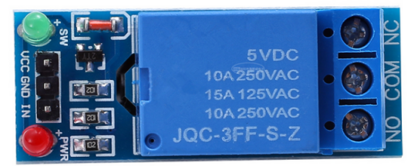 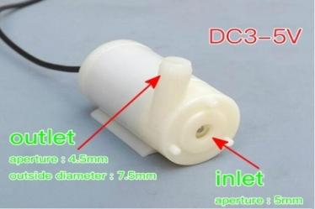

5V 1-way relay Water Storage

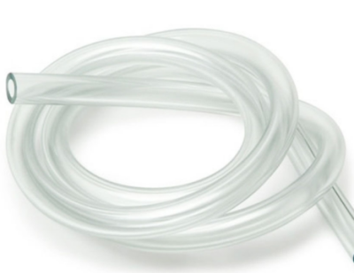 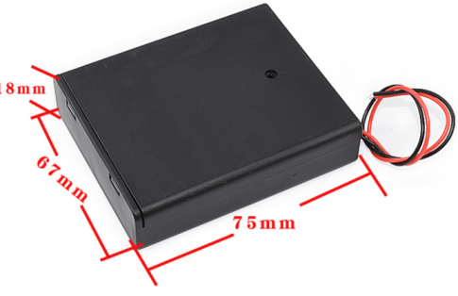

Water Pump Hose Battery box 5

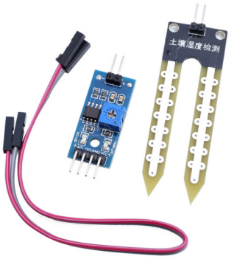 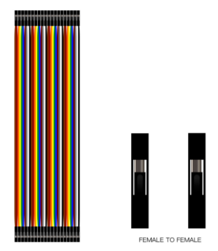

Soil Testing Modules Female-to-female DuPont Cable

**Device parameters**

**Soil moisture detection module**

1, Wiring instructions

VCC: external DC 3.3V-5V

GND: external GND

DO: digital output interface (0 and 1)

AO: analog output interface

2, The use of instructions

①The module in the soil humidity does not reach the set threshold, DO port output high level, when the soil humidity exceeds the set threshold, the module D0 output low level;

②Digital output D0 can be directly connected to the microcontroller, through the microcontroller to detect the high and low levels, thereby detecting the soil moisture;

③Digital output DO can directly drive relay module, buzzer module, etc., which can form a soil moisture alarm device;

④Analog output AO can be connected to the AD module, through the AD conversion, you can get a more accurate value of soil moisture. It can be directly connected to Arduino without AD module conversion.

**Relay Module**

1, Wiring instructions

VCC: connected to the positive pole of the 5V power supply (according to the relay voltage supply)

GND: connected to GND

IN: Relay module signal trigger terminal (low-level trigger effect of the module)

Note:

High-level triggering refers to a triggering mode with the positive voltage of VCC terminal connected to the trigger terminal, when the trigger terminal has a positive voltage or reaches the triggering voltage, the relay will be activated.

Low level trigger refers to a triggering method that connects the negative voltage of the GND terminal to the trigger terminal. When there is 0V voltage at the trigger terminal or the voltage is low enough to trigger, the relay will be activated.

2, Wiring method for normally open end

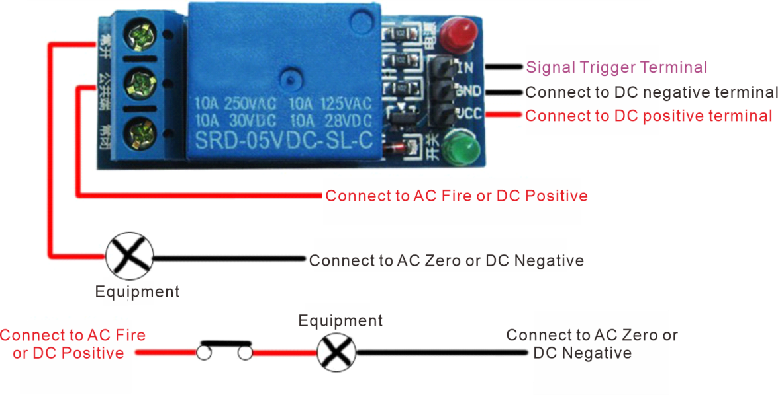

Principle

When the signal trigger terminal has a low level trigger, the common terminal and the normally open terminal will be connected, the device has power and work.

3, Normally closed wiring method

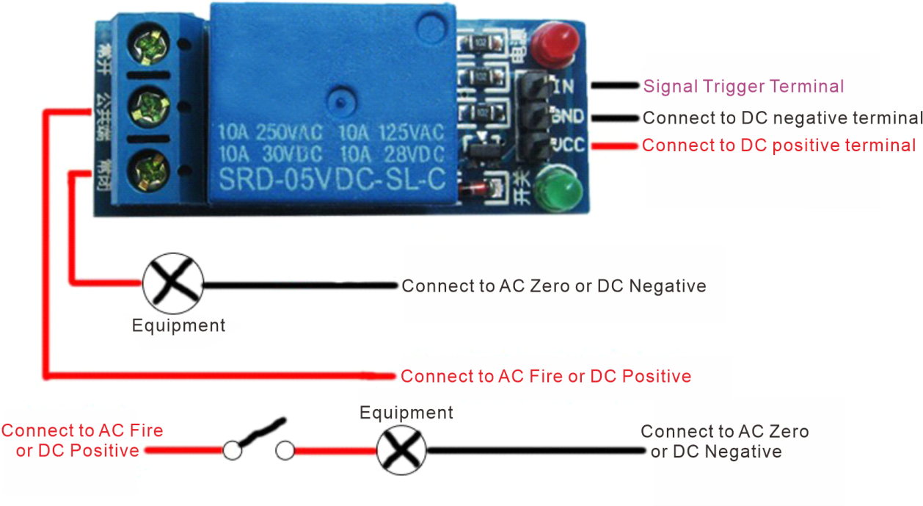

Principle

When there is a low-level trigger at the signal trigger terminal, the common terminal and the normally closed terminal will be disconnected, and the device will not work without power (in this experiment, we use the "normally closed terminal wiring method").

**Connection Schematic**

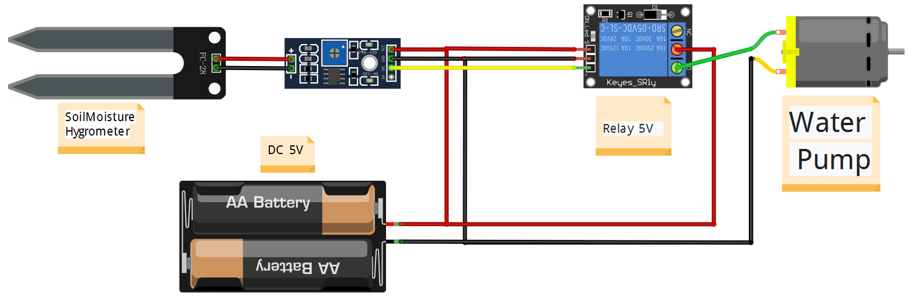

**Reasoning**

**First: humidity detection**

Detecting soil moisture, need "soil moisture detection module" to complete, we all know that the earth, people, metal, water are conductors, and we also know: under normal circumstances, when the human skin is dry, the human body, the greater the resistance, and vice versa, the smaller, similarly, the amount of water in the soil will change the size of the resistance. According to Ohm's law: I = U/R, after the deformation: U = I * R, U: voltage, unit is V; R: resistance, unit is Ω; I: current, unit is A. When the soil contains more water, the resistance will be small, according to the formula to get the voltage will be small, of course, the resistance can not be 0, naturally, the voltage is not possible to 0, so in the module to add a piece of voltage comparator chip to compare the collected voltage and power supply voltage (understand). So add a voltage comparison chip on the module, used to compare the collected voltage and the supply voltage (it is good to know that there is such a thing, the role of this thing). After the completion of this series of operations, will be in the digital and analog end of a specific value, where the digital output 0 or 1, analog output 0-1023, in this module, when the soil contains less water output high level, when sufficient moisture output low level.

**Second: Relay control**

Sensor data collected and processed will output the corresponding value, with the wire will be connected to the sensor and the relay can control the relay, the role of the relay can be understood as a switch, it is actually used to control some of the electrical appliances working in high voltage, and the light switch at home for a reason, it is important to note here is that we are using the relay is triggered by a low level, on the other side of the relay, there areA common terminal, there is a normally closed and normally open, normally open and common is in the open state, normally closed and common is on state, when the relay is triggered by the low level, the relay internal spring copper in the magnetic pull to change the state, at this time, normally open and common is in the state of on state, normally closed and common is off state, the relay is low-level trigger, the relay internal spring copper in the magnetic pull change state, at this time, normally open and common is in the state of on state, the normally closed and common is off state, the relay is low level trigger, the relay internal spring copper is in the state of on state.

Analysis: the soil contains less water when the output level is high, sufficient water when the output level is low, the relay is triggered for the low level, that is to say, the relay was triggered when the soil moisture is very sufficient, then since the water is very sufficient, there is no need to water, the pump should stop working, the pump stops working, the public and the other end should be in the disconnected state. In the previous, we said, low-level state, the normally closed end of the relay will be transformed into a normally open end, the natural public end and the normally closed end is disconnected, the pump stopped working, on the contrary, when the soil lack of moisture, the sensor output high level, the relay will not change the state, then at this time, the public end and the normally closed end is the state of conduction, the pump will naturally work.

**workflow chart**

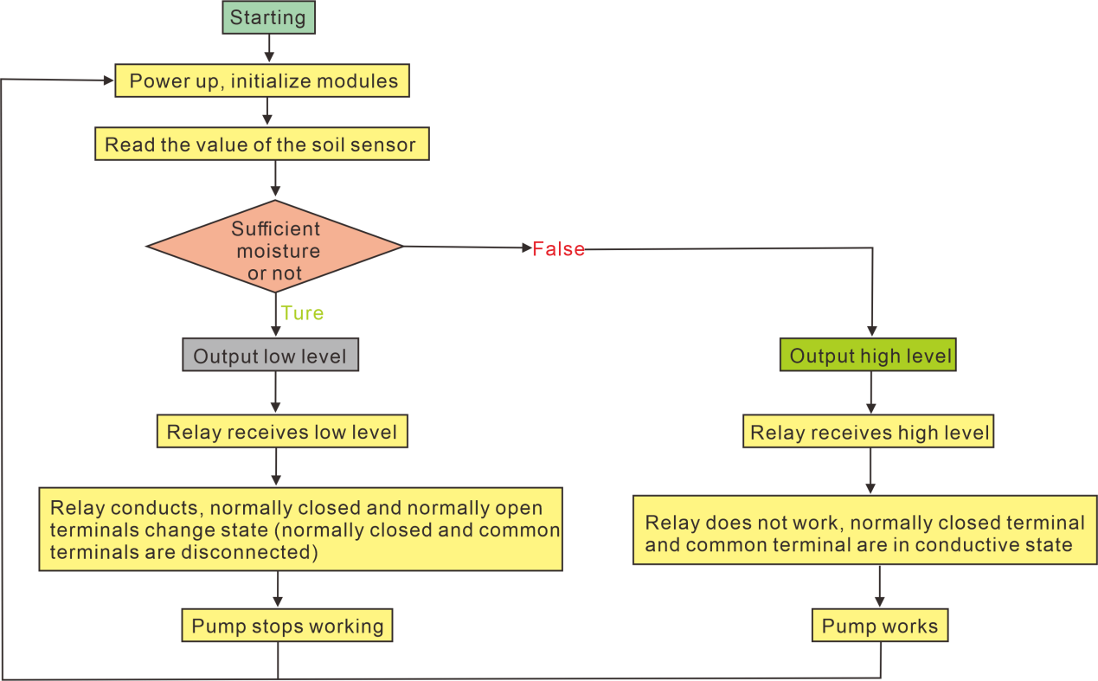

**Vantage**

The system is controlled directly using the high and low levels of the sensor, without the need for an external microcontroller, no programming language, and low cost, simple circuitry, suitable for introductory hobbyists with no basic knowledge of circuits.

**Significance**

Through this experiment, you can learn and master the working principle of each module, the most basic circuit wiring, and cultivate the fun of electronic creation. In addition, the intelligent watering system can control the soil moisture by itself, which can give us more time to do other things in our busy life.

**Project Steps**

1. Connect the soil detection module to the probe .

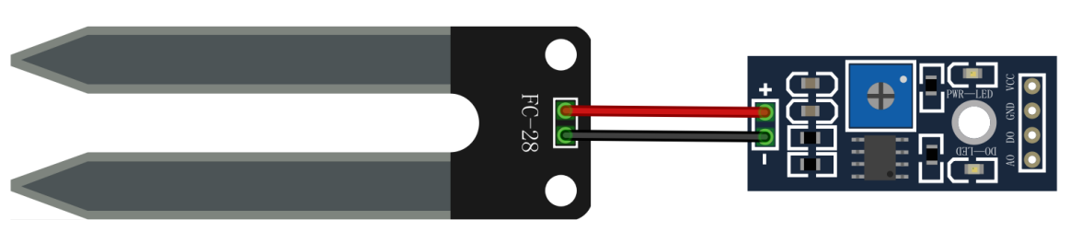

1. Connect the soil detection module power supply and relay power supply to the battery box.

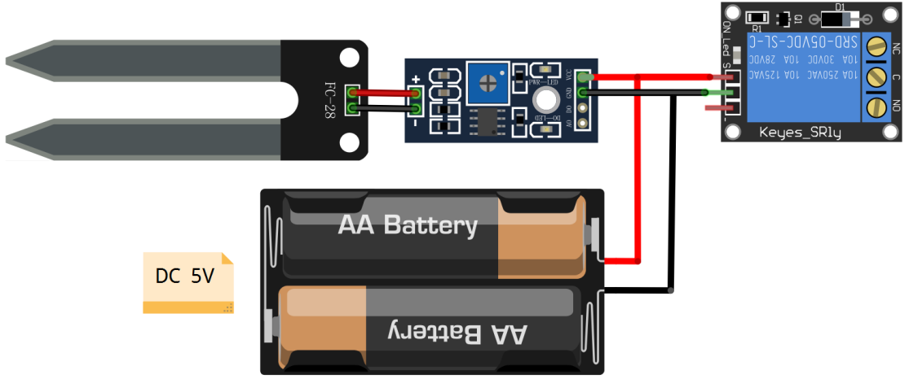

1. Connect the signal output terminal (DO) of the soil detection module to the signal input terminal (IN) of the relay.

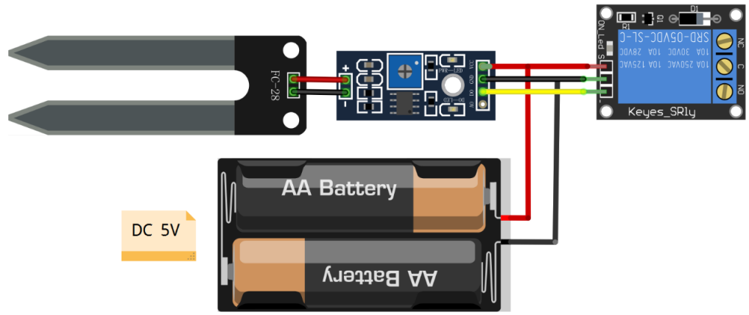

1. Connect the negative terminal of the pump to the negative terminal of the battery and the common terminal of the relay to the positive terminal of the battery.

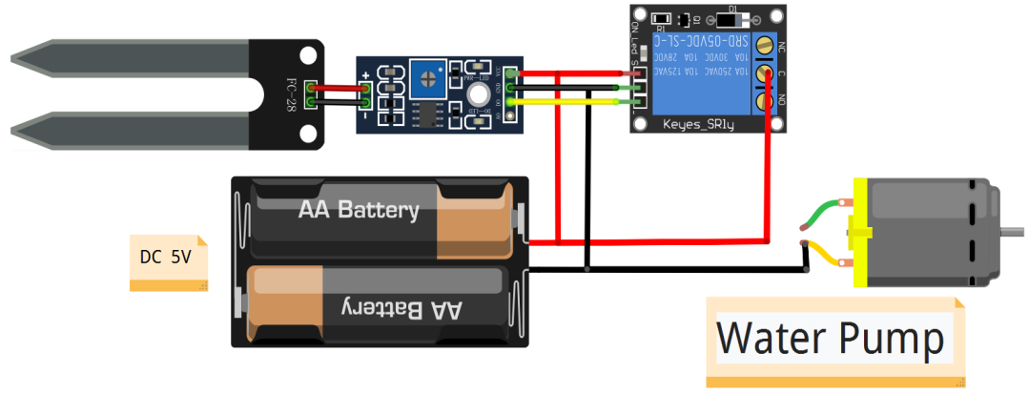

1. Connect the positive terminal of the pump to the normally closed terminal of the relay.At this point, the wiring part of the project is completed.

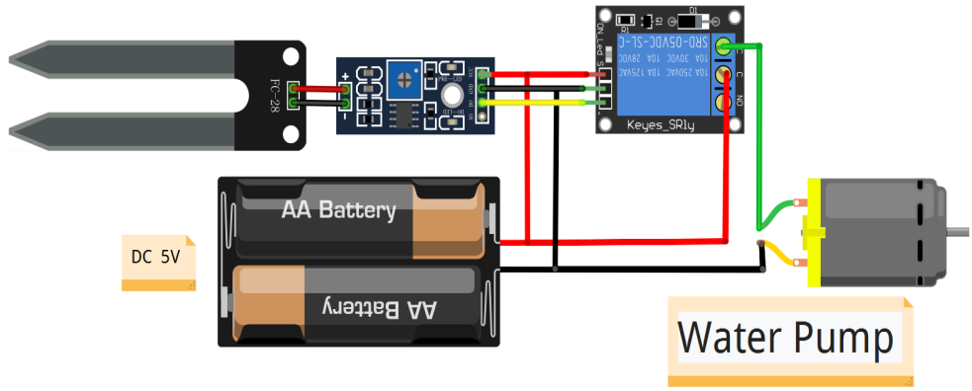

**Experimental Phenomena**

Insert the Soil Detection Module probe into dry soil and the pump starts pumping water. When there is enough water in the soil, the water pump stops working to finish watering.