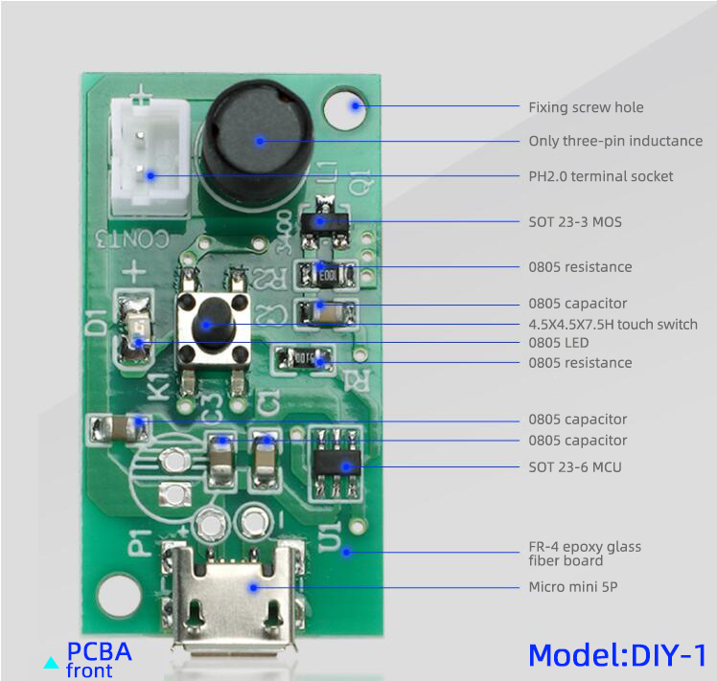
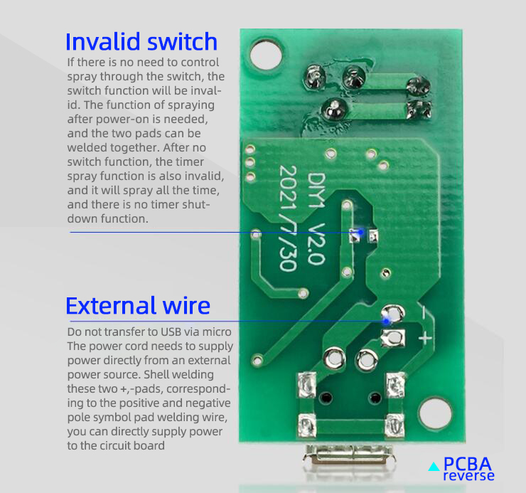
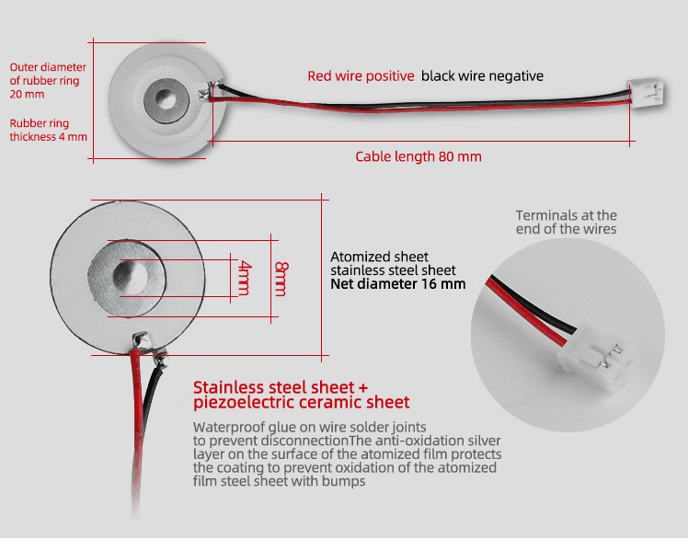
1, fine spray particles, heavy fog volume, not wet desktop.
2. Low driving voltage, low power, low impedance, stable waveform and high conversion efficiency;
3. Atomizing spray, 5um superfine spray aperture and 740 super dense spray hole.
4. The protective coating process of anti silver oxide layer on the surface of atomization sheet has long service life.

Circuit board parameters
Circuit board product voltage DV 5V, current 300mA, power 2W, frequency 108khz, fixed frequency single chip microcomputer.
Drive plate size: length 35 × Width 20 × 17mm high.
The chip has the function of automatic timing shutdown. 5V USB power supply mode, which can be powered by Android mobile phone charging cable.

